**Name: Ahmed Medhat Ramadan**

**Class: 3A**

**School: WE Alex**

**Task Number: Unit 25 Task 2**

**Task Name: DERN-Support IT System – Design Documents**

**Design Documents**

**1. Functional and Non-Functional Requirements:**

* **Functional Requirements:**

**1. User Management:**

- User registration, login, and authentication.

- Role-based access control (Admin, Customer).

**2. Service Request Management:**

- Customers can create and track service requests.

- Admins can assign requests to technicians.

**3. Product & Inventory Management:**

- Admins can add, update, or delete products.

- Customers can browse products and check availability.

**4. Reporting & Analytics:**

- Admin dashboard for tracking status.

* **Non-Functional Requirements:**

1. **Performance**: The system should handle 1000+ concurrent users.

2. **Usability**: Intuitive UI for easy navigation using Bootstrap v5.

3. **Availability**: 99.9% uptime guarantee with proper failover mechanisms.

4. **Maintainability**: Modular code structure for easy updates and debugging.

**2. Visual Design Documentation:**

- **Wireframes**: Created in **Figma** to design the UI for customer, admin, and technician dashboards.

**- UI Components**: React.js components styled with **Bootstrap v5 and FontAwesome icons.**

**- Navigation Flow:** Users move through authentication, dashboard, service requests, products, and installations.

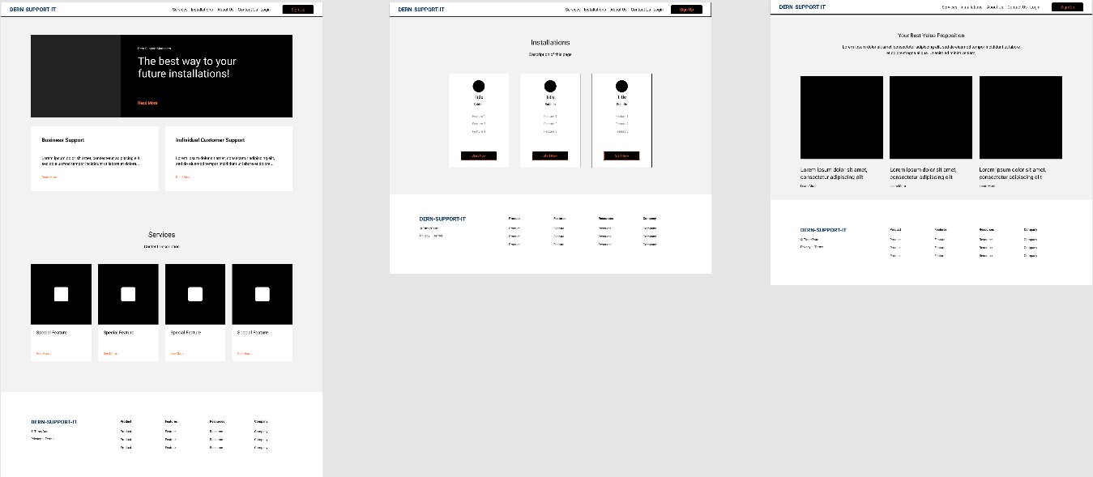

**3. Entity-Relationship Diagram (ERD):**

**- Tool Used: PHPMyAdmin**

- **Key Tables (Mapped to Database Schema)**

|  |
| --- |
| **Table: users** |
| **Columns:** |
| **user_id (Primary Key, INT, AUTO_INCREMENT)** |
| **name (VARCHAR)** |
| **email (VARCHAR, UNIQUE)** |
| **phone (VARCHAR)** |
| **created_at (TIMESTAMP)** |
| **role (ENUM: 'admin', 'user')** |
| **password (VARCHAR)** |

|  |
| --- |
| **Table: requests** |
| **Columns:** |
| **request_id (Primary Key, INT, AUTO_INCREMENT)** |
| **user_id (Foreign Key → users.user_id, CASCADE)** |
| **technician_id (Foreign Key → technicians.technician_id, SET NULL)** |
| **device_type (VARCHAR)** |
| **issue_description (TEXT)** |
| **status (ENUM: 'Pending', 'In Progress', 'Completed')** |
| **created_at (TIMESTAMP)** |

|  |
| --- |
| **Table: technicians** |
| **Columns:** |
| **technician_id (Primary Key, INT, AUTO_INCREMENT)** |
| **name (VARCHAR)** |
| **email (VARCHAR, UNIQUE)** |
| **phone (VARCHAR)** |
| **skillset (TEXT)** |
| **availability (TINYINT, 1 = Available, 0 = Unavailable)** |
| **created_at (TIMESTAMP)** |

|  |
| --- |
| **Table: payments** |
| **Columns:** |
| **payment_id (Primary Key, INT, AUTO_INCREMENT)** |
| **user_id (Foreign Key → users.user_id, CASCADE)** |
| **request_id (Foreign Key → requests.request_id, CASCADE)** |
| **amount (DECIMAL)** |
| **payment_status (ENUM: 'Pending', 'Completed', 'Failed')** |
| **transaction_date (TIMESTAMP)** |

|  |
| --- |
| **Table: products** |
| **Columns:** |
| **product_id (Primary Key, INT, AUTO_INCREMENT)** |
| **name (VARCHAR)** |
| **description (TEXT)** |
| **price (DECIMAL)** |
| **image_url (VARCHAR)** |
| **created_at (TIMESTAMP)** |
| **updated_at (TIMESTAMP, ON UPDATE CURRENT_TIMESTAMP)** |

|  |
| --- |
| **Table: feedback** |
| **Columns:** |
| **feedback_id (Primary Key, INT, AUTO_INCREMENT)** |
| **user_id (Foreign Key → users.user_id, CASCADE)** |
| **request_id (Foreign Key → requests.request_id, CASCADE)** |
| **rating (INT, CHECK between 1-5)** |
| **comments (TEXT)** |
| **created_at (TIMESTAMP)** |

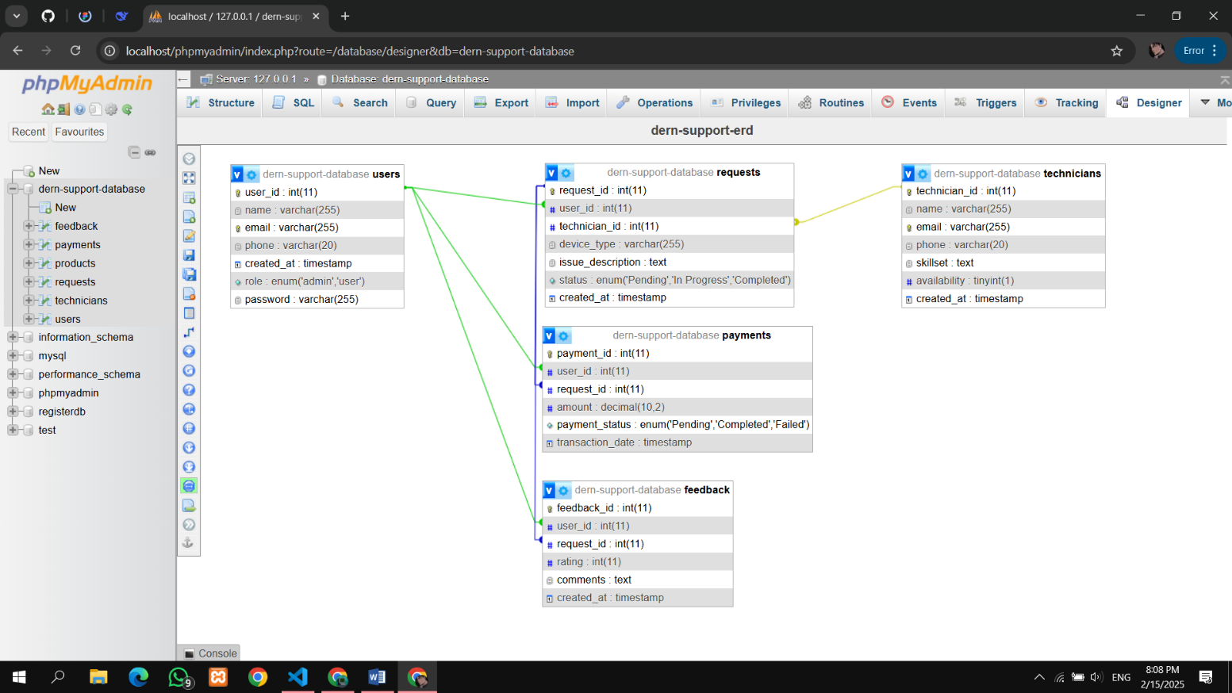

**4. Feedback Documentation:**

**Stakeholder Feedback & Changes Implemented:**

* **Customer Portal Enhancements:**
  + Added live tracking for service requests based on feedback.
  + Improved mobile responsiveness for better accessibility.
* **Admin Dashboard Improvements:**
  + Enhanced reporting features with detailed technician performance analytics.
  + Introduced filters for better job tracking.
* **Security Upgrades:**
  + Implemented Two-Factor Authentication (2FA) for admins.
  + Strengthened API security with rate limiting and validation.

**5. Justification of Design Decisions:**

* **React.js for Frontend:** Chosen for its component-based structure and fast rendering capabilities.
* **Node.js & Express.js for Backend**: Provides scalable and efficient API handling.
* **PHPMyAdmin for Database Management**: Offers easy management of MySQL-based databases.
* **Figma for Wireframing:** Enables quick prototyping and design collaboration.
* **Bootstrap v5 & FontAwesome**: Ensures a clean, responsive, and accessible UI.

**This document outlines the key design aspects, technical decisions, and iterative improvements made based on feedback to develop an effective full-stack solution for Dern-Support.**